# Assignment

1. **Create a virtual network with 2 subnets. Each subnet should have 16 Ips only**

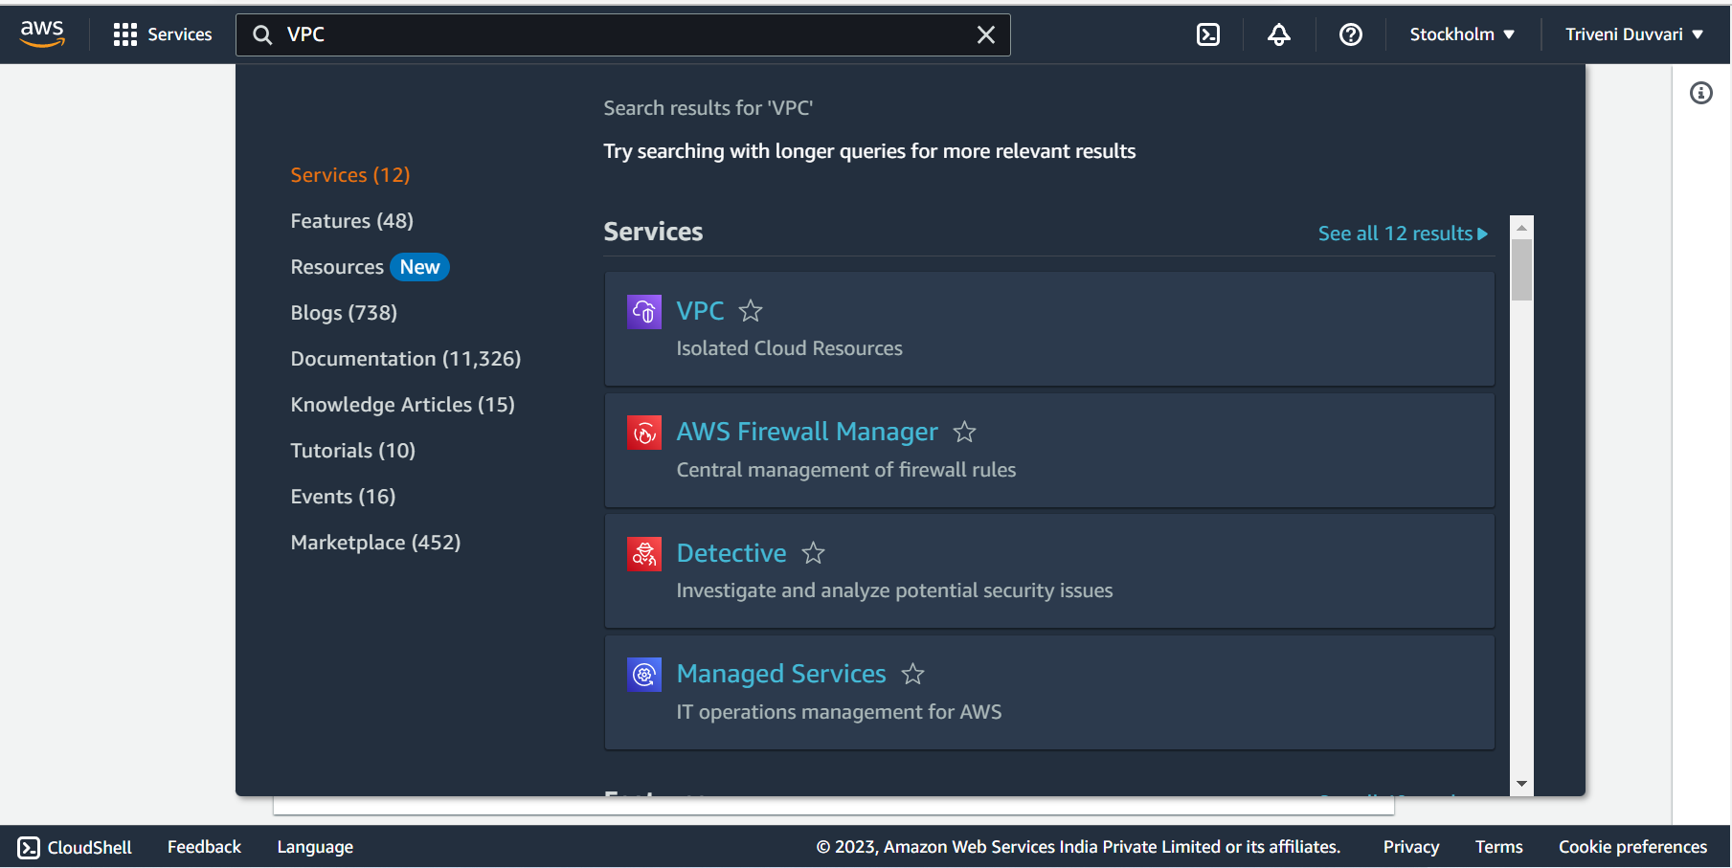

Log in to the AWS Management Console and open the Amazon VPC (Virtual Private Cloud) service

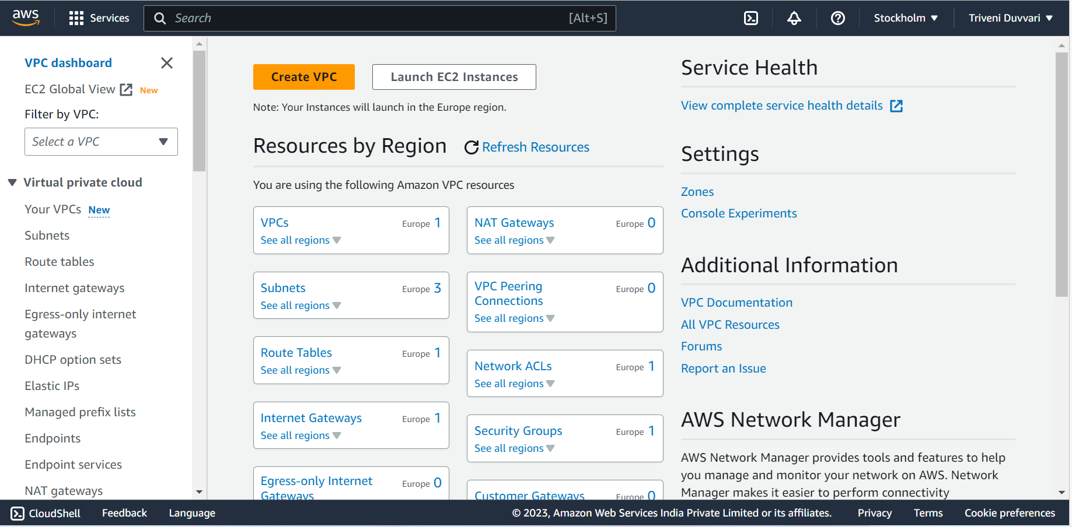

Click on Create VPC

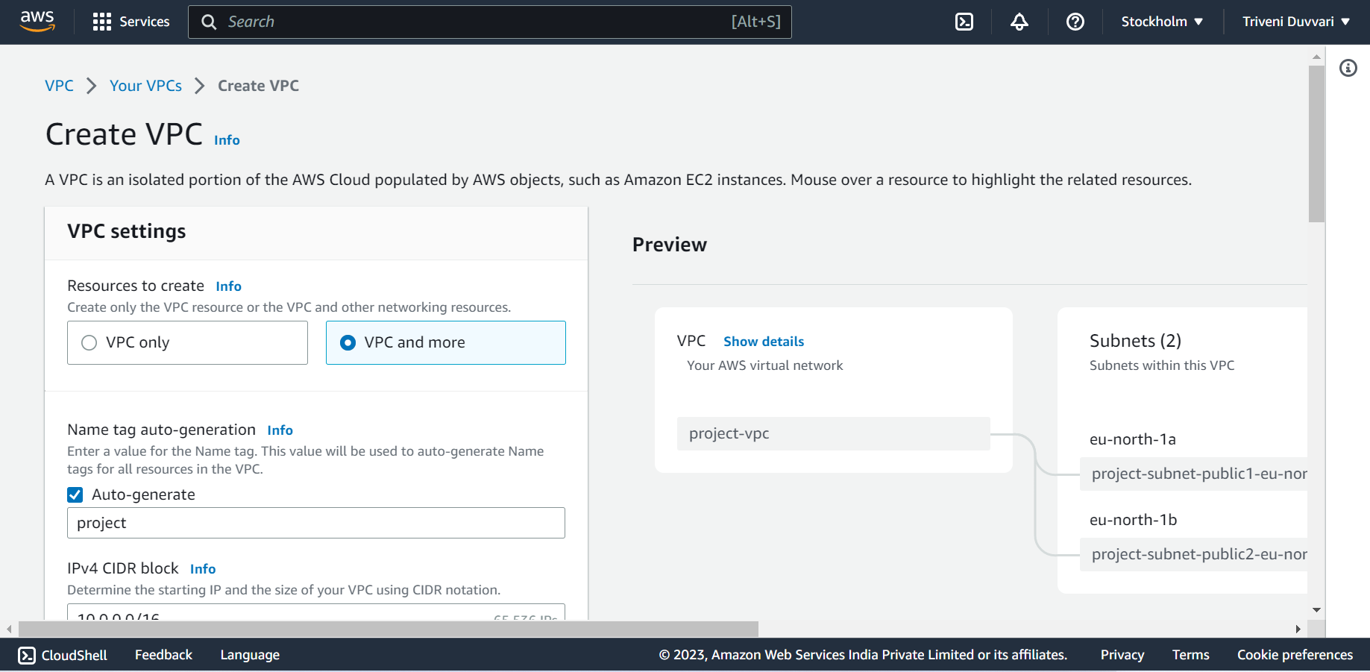

Select vpc and more options

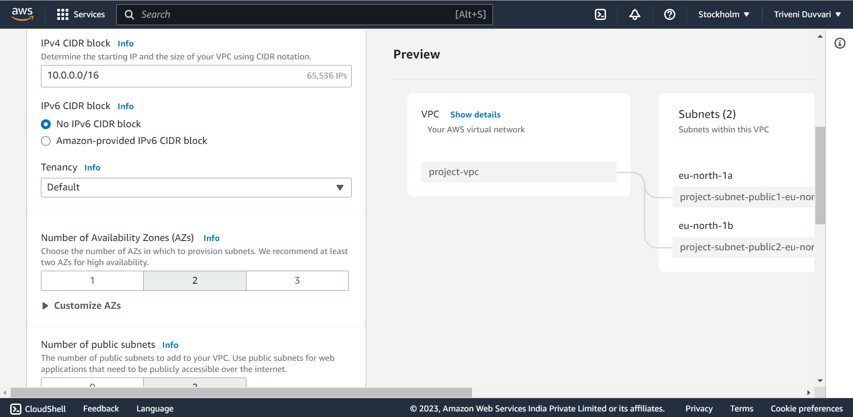

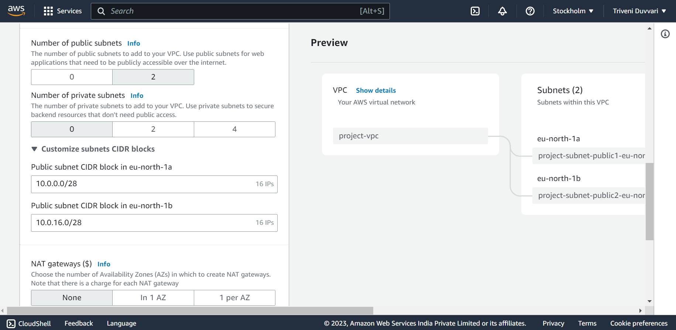

Select the number of subnets to 2 and change IPs to 16

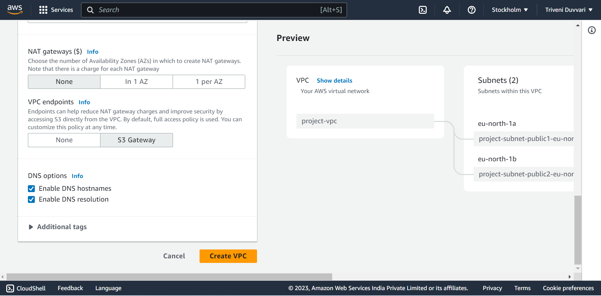

Click on VPC

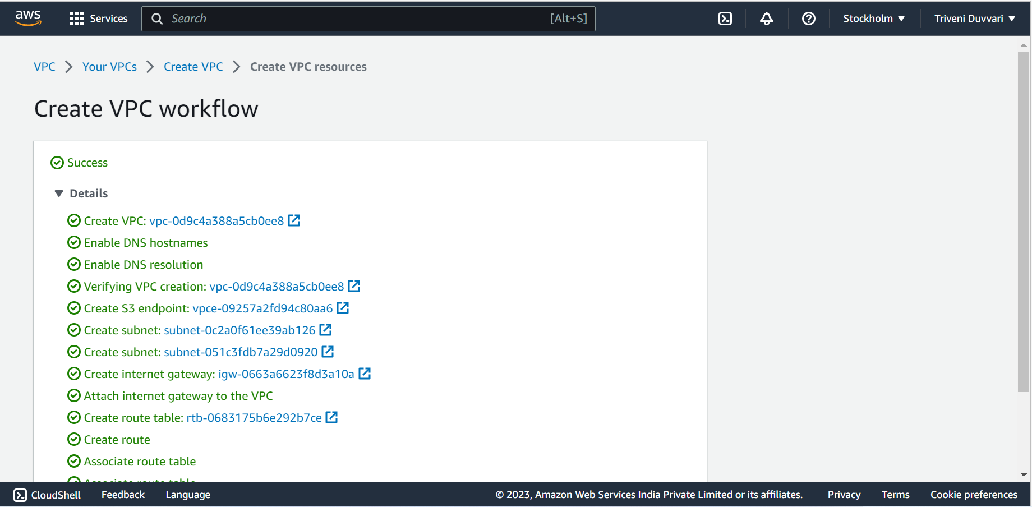

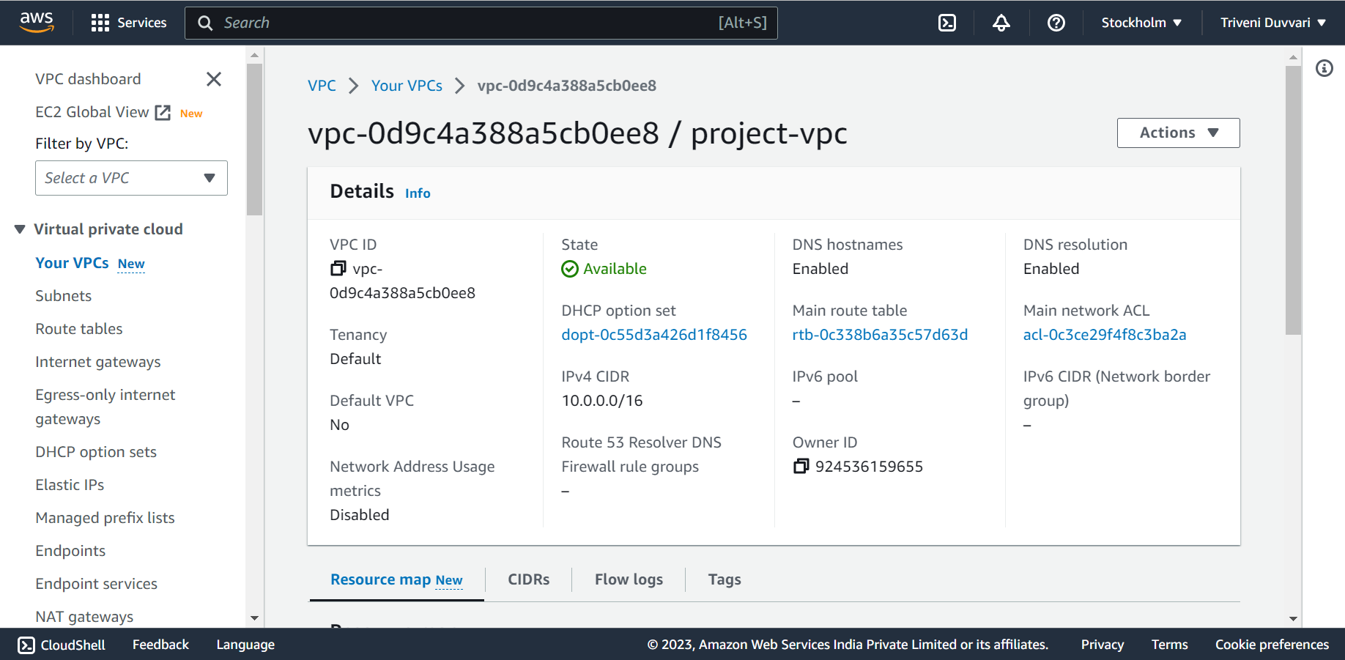

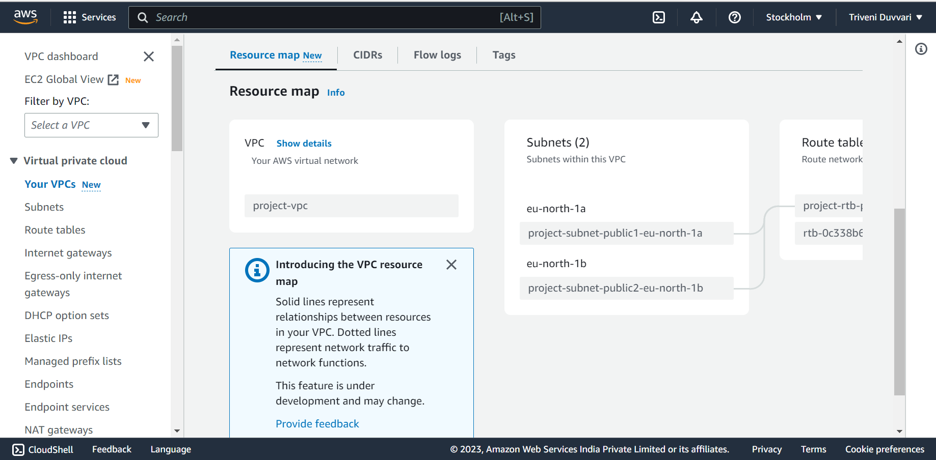

2. **Create a Lambda that should trigger as soon as you upload a file in the S3 bucket.**

**Function should be able to print the name of the file uploaded in the function.**

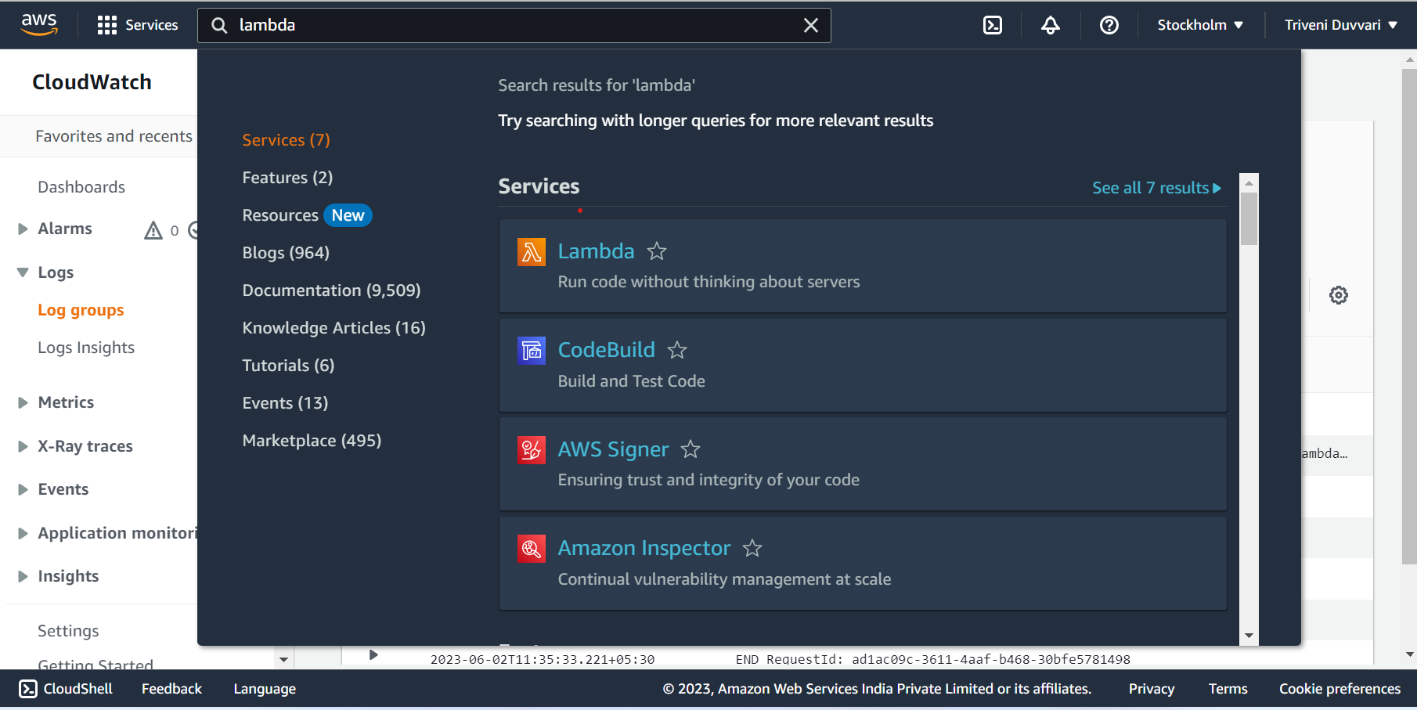

Go to the AWS Management Console and navigate to the Lambda service

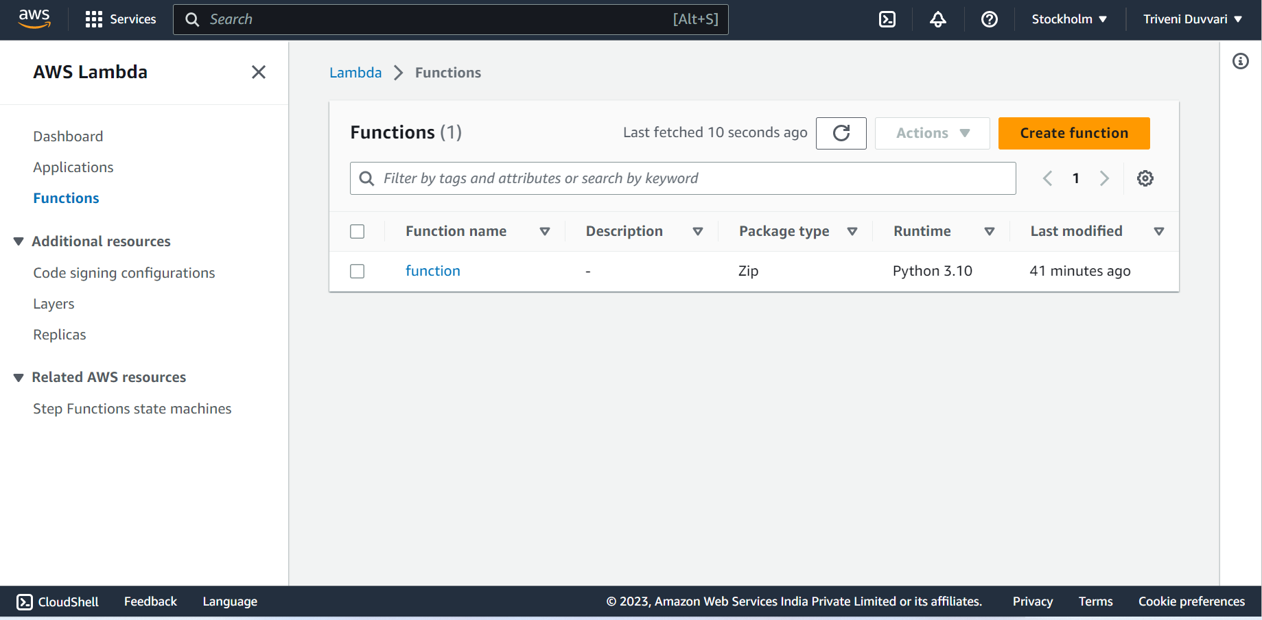

Click on "Create function"

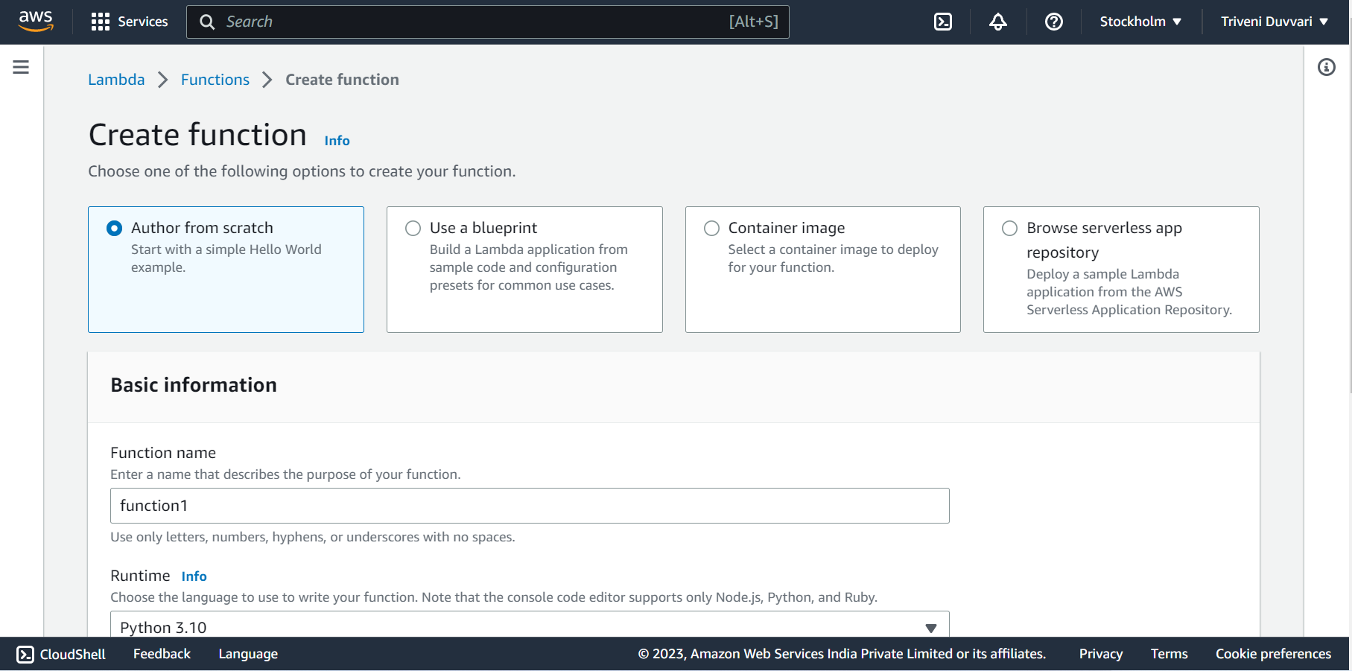

choose "Author from scratch"

Give your function a name and select the runtime as "Python 3.x"

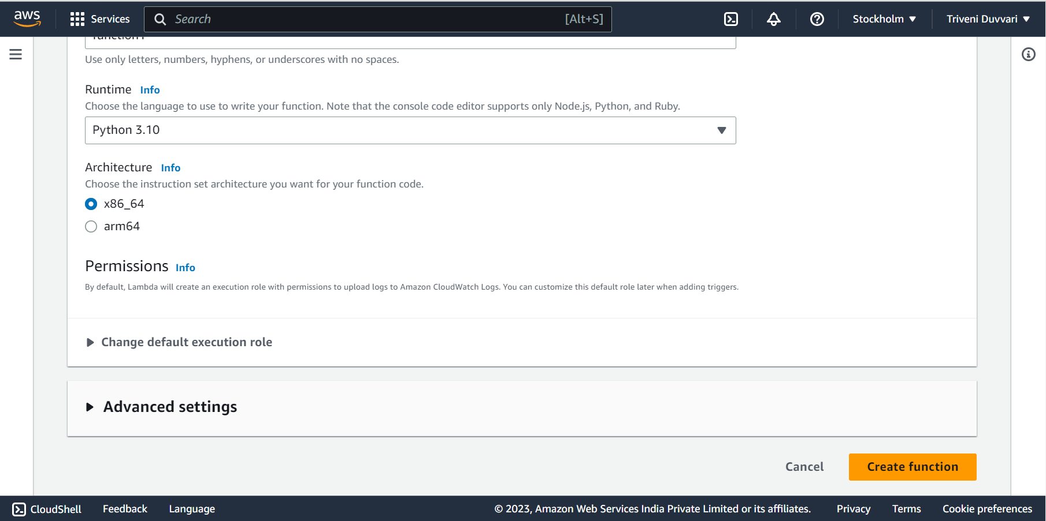

Click on "Create function" to create the Lambda function

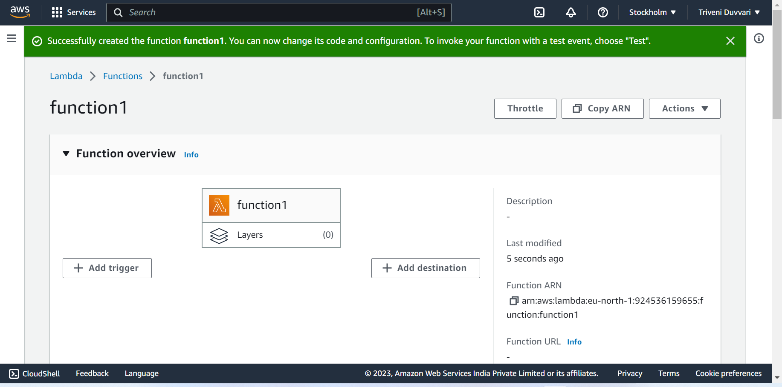

Click on Add triggers

Before Adding trigger we need to create the bucket in S3 for that :

Go to the AWS Management Console and navigate to the Amazon S3 service

Click on buckets

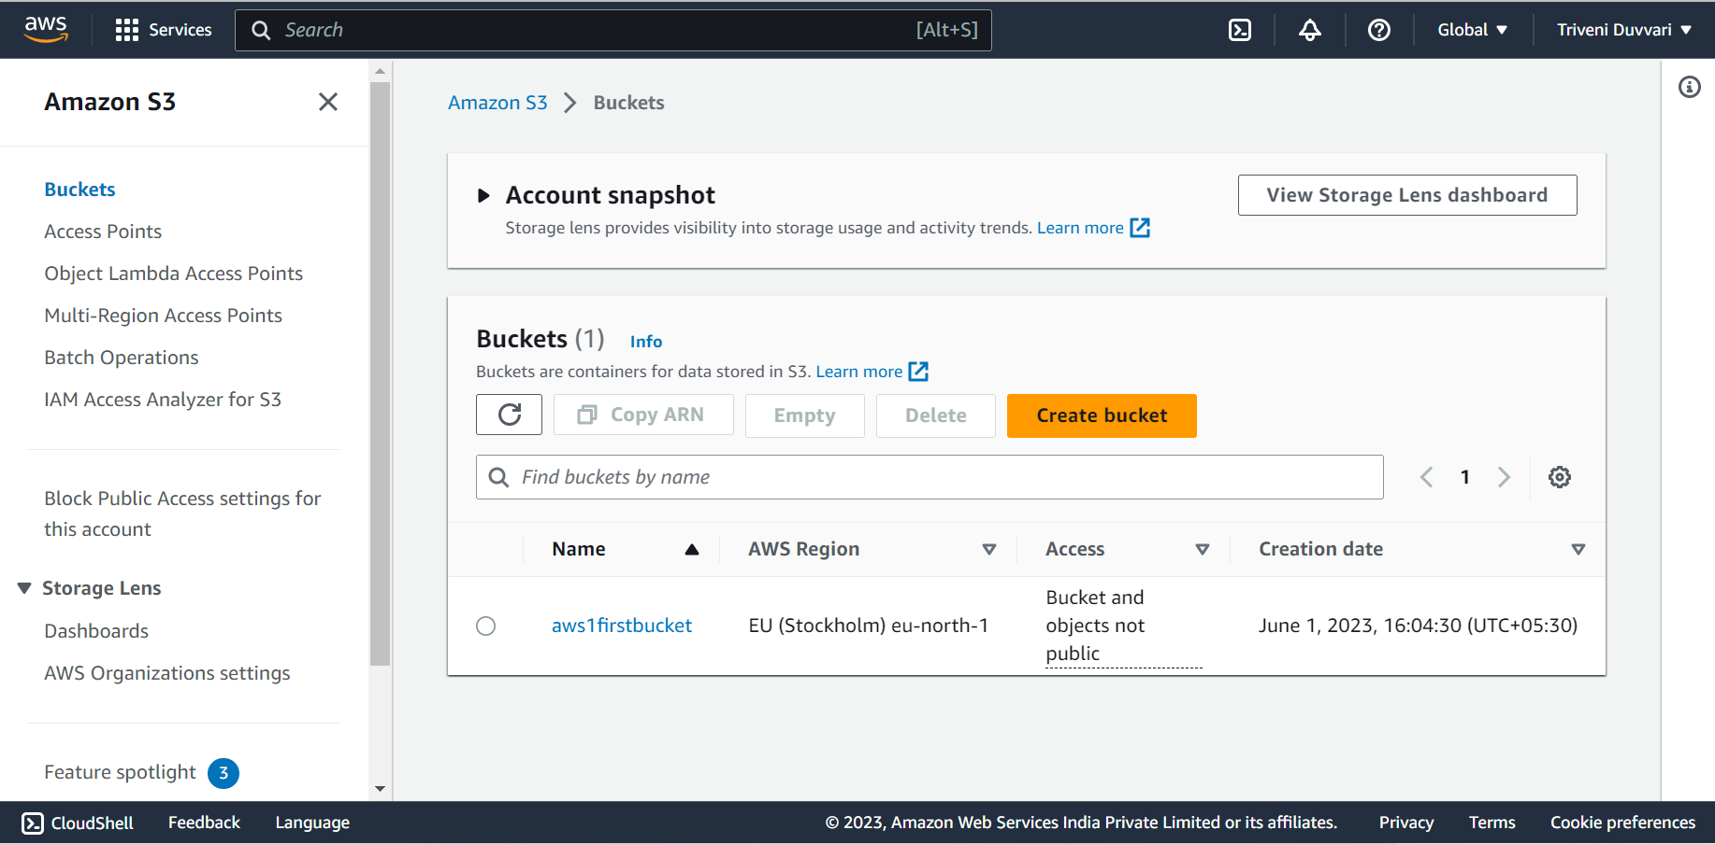

Click on “Create Bucket”

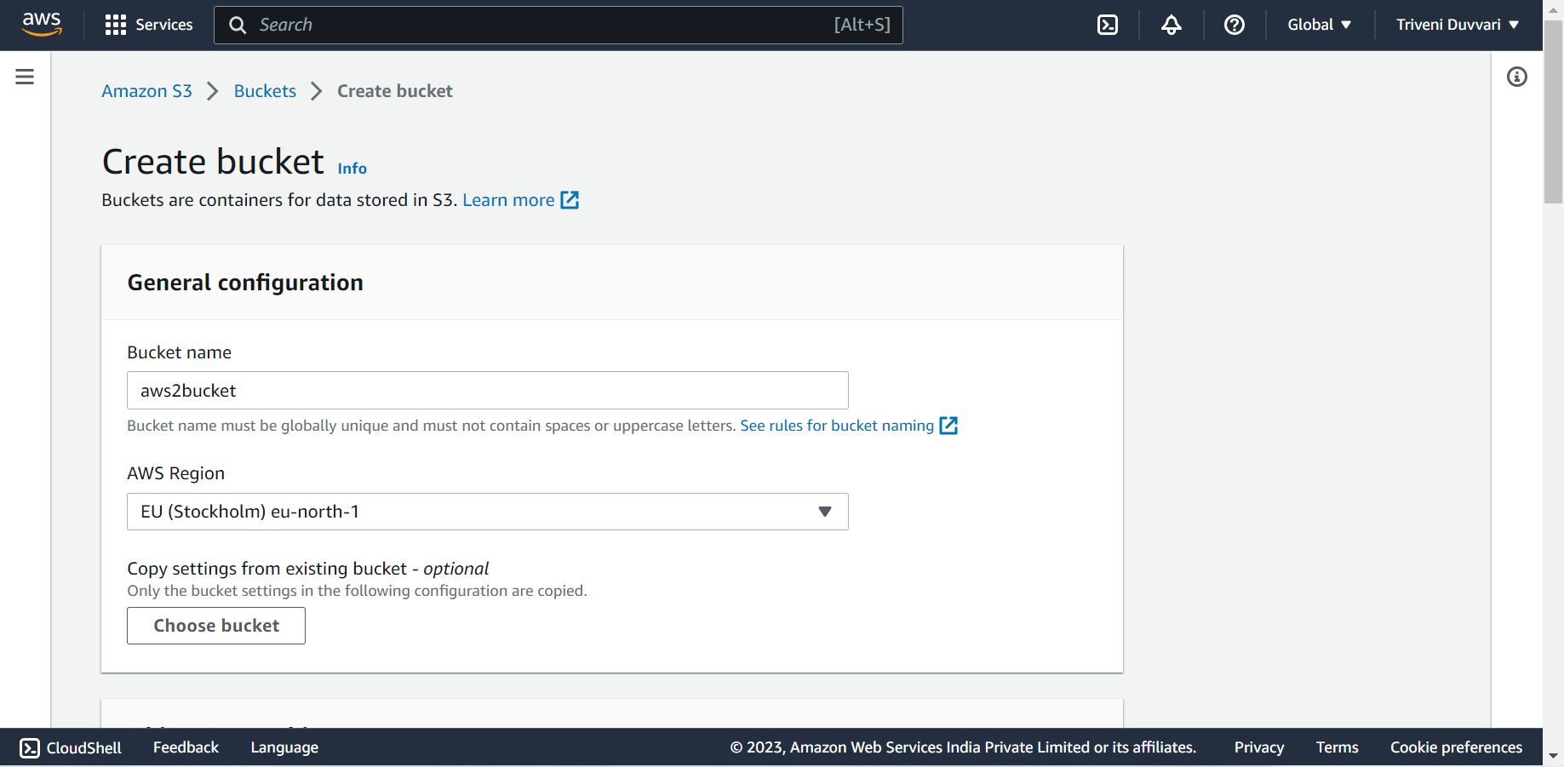

Fill the details and click on create

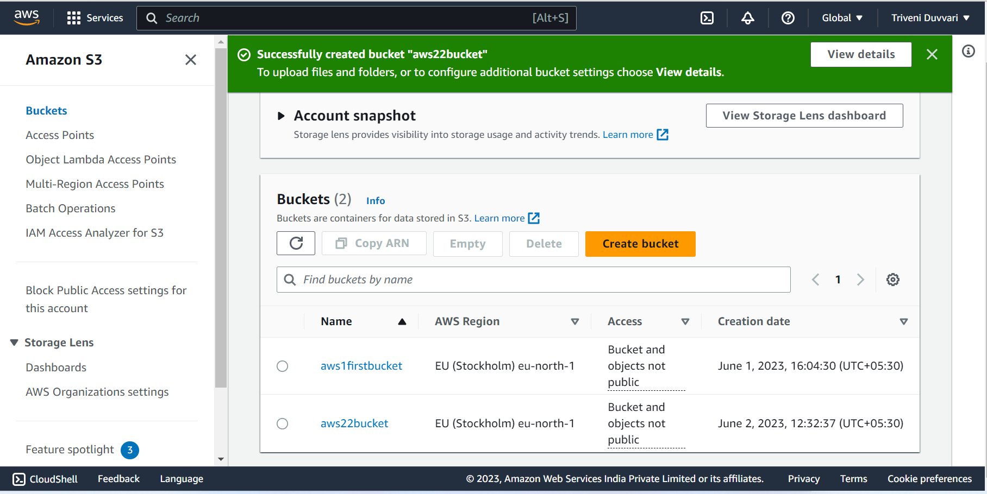

Now in Add Trigger Choose the type as S3 and choose the bucket we have created

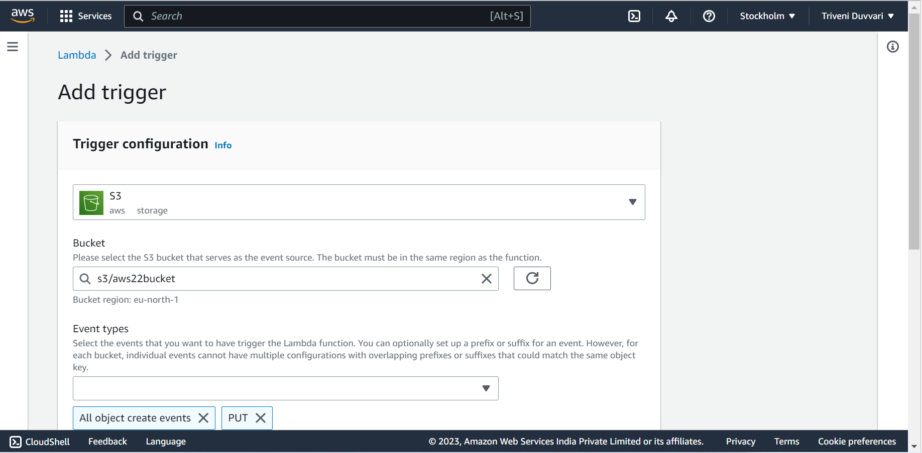

Select the Event Types

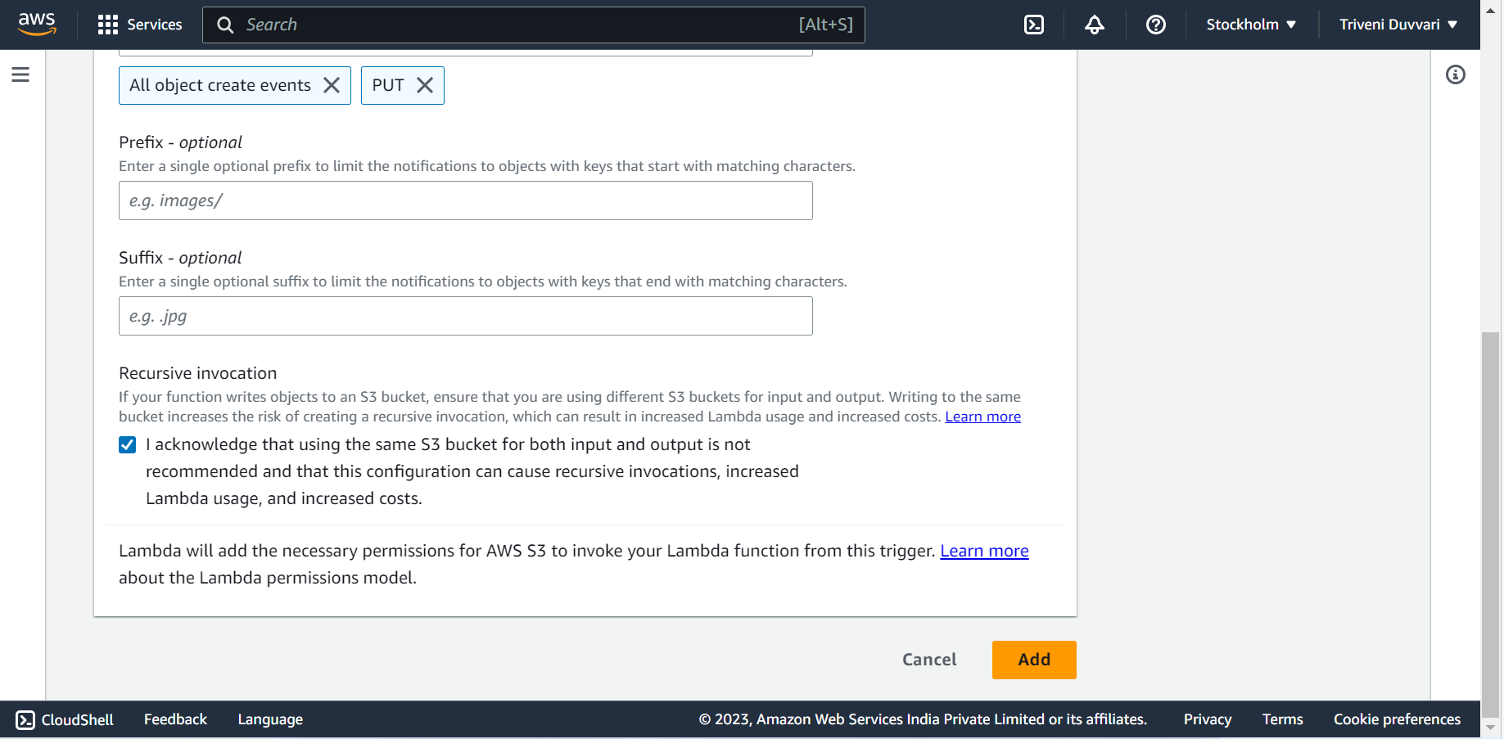

Click on Add

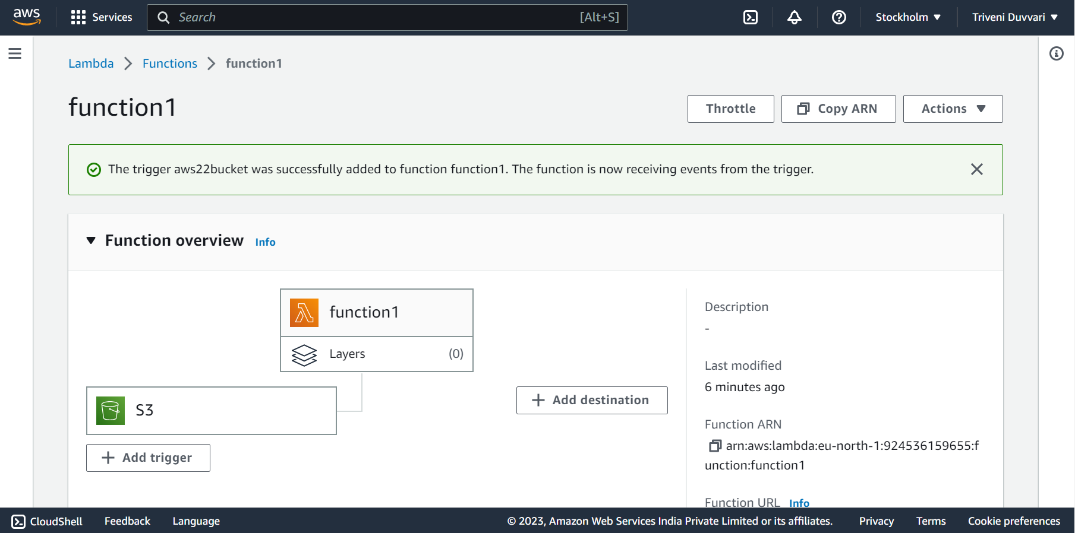

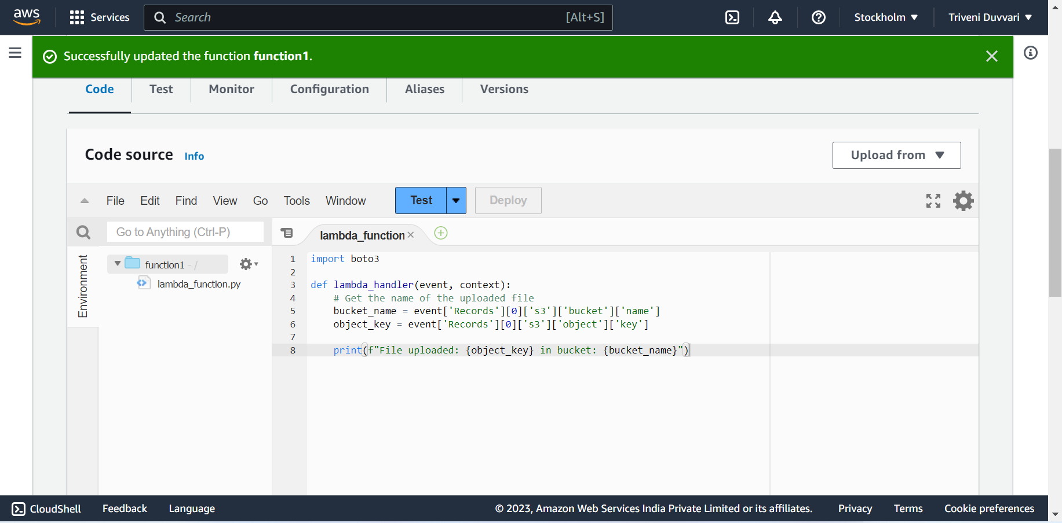

Change the code accordingly and click on update and deploy

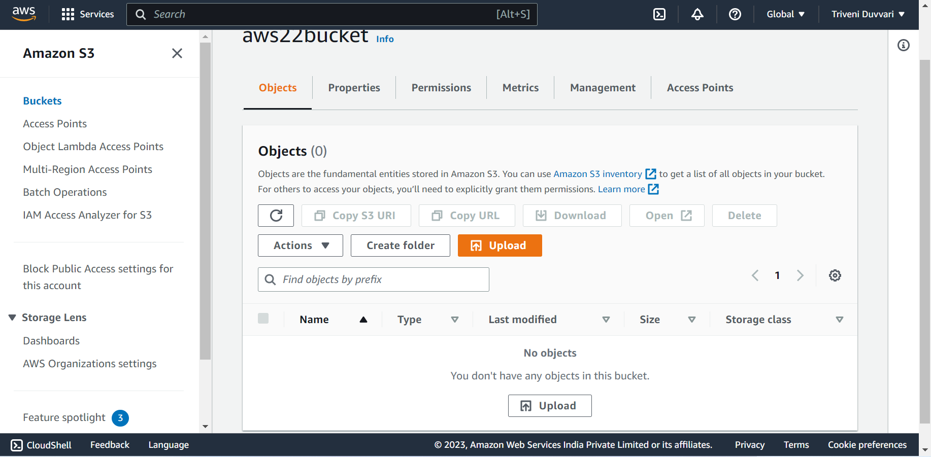

Now Upload the file in the bucket as follow.

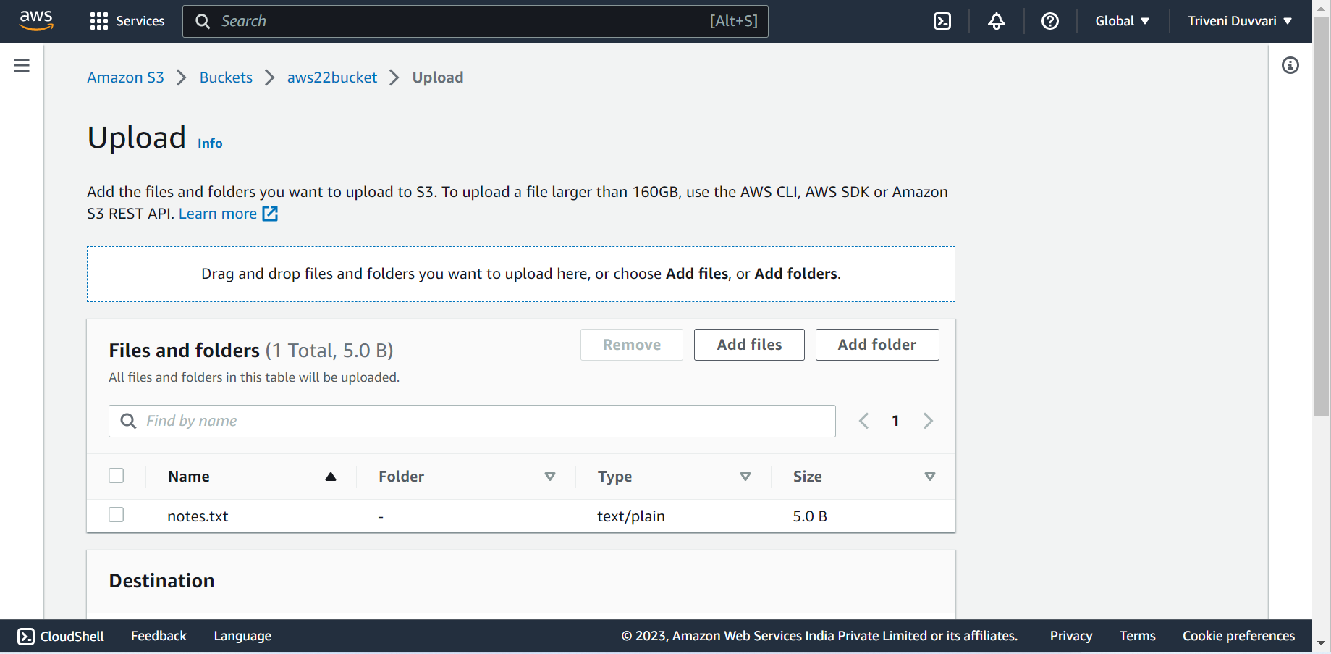

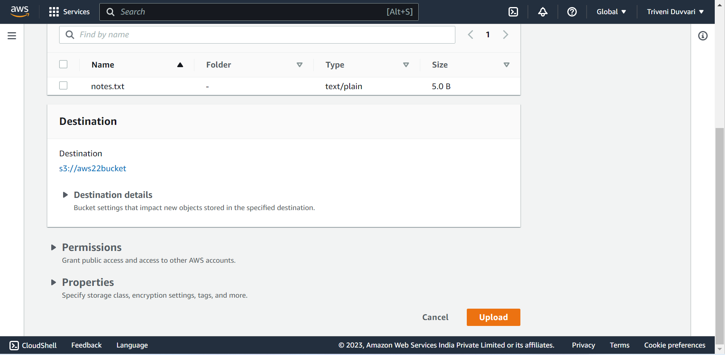

click on upload

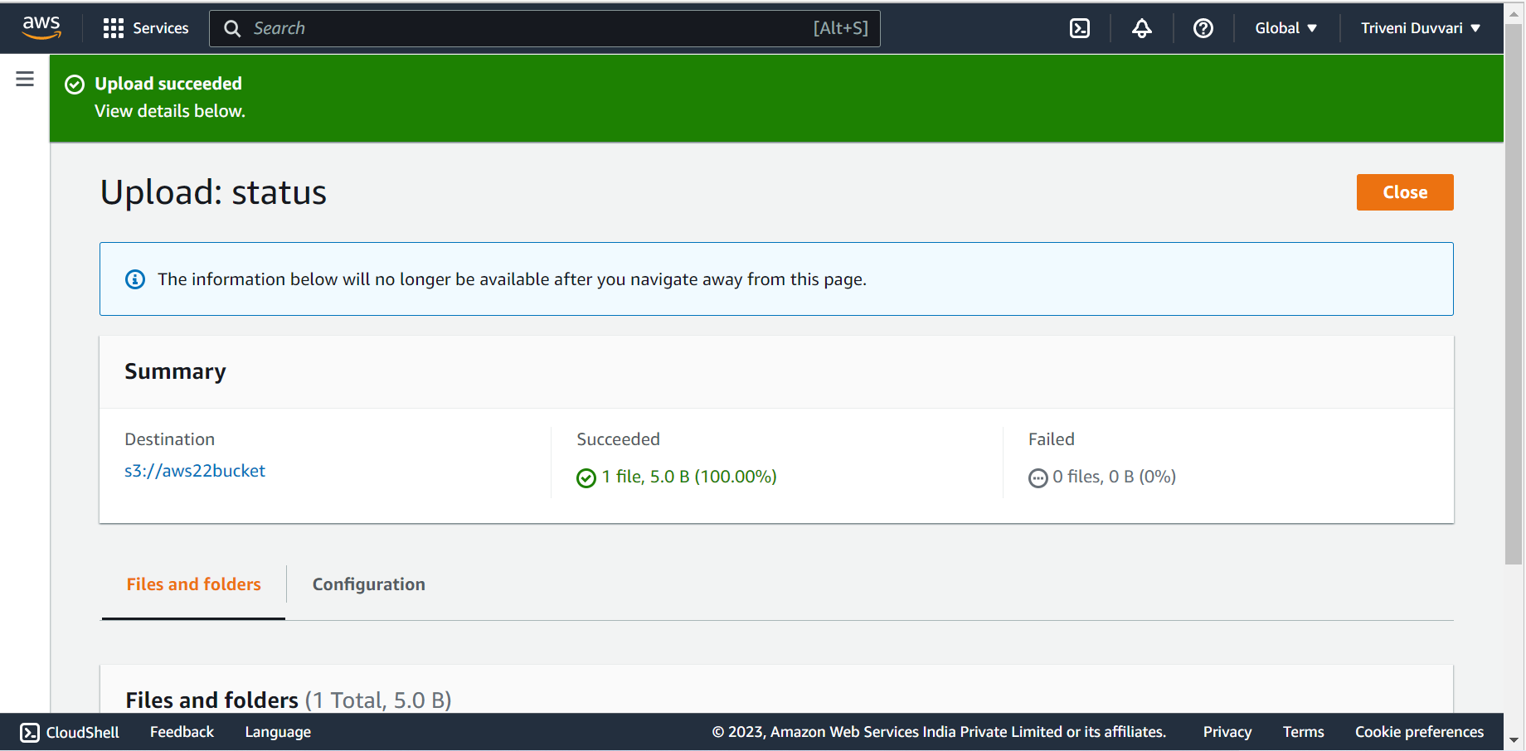

Now go to CloudWatch service

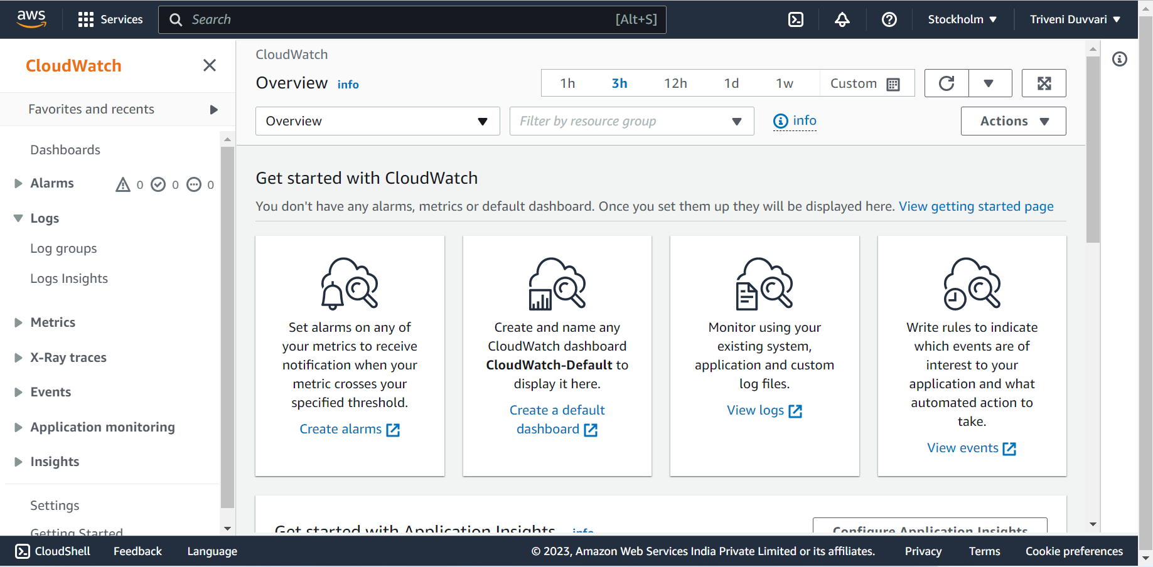

Click on log groups

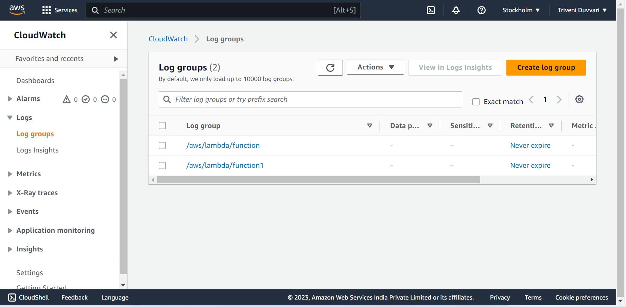

We can observe the logs of the function and click on function

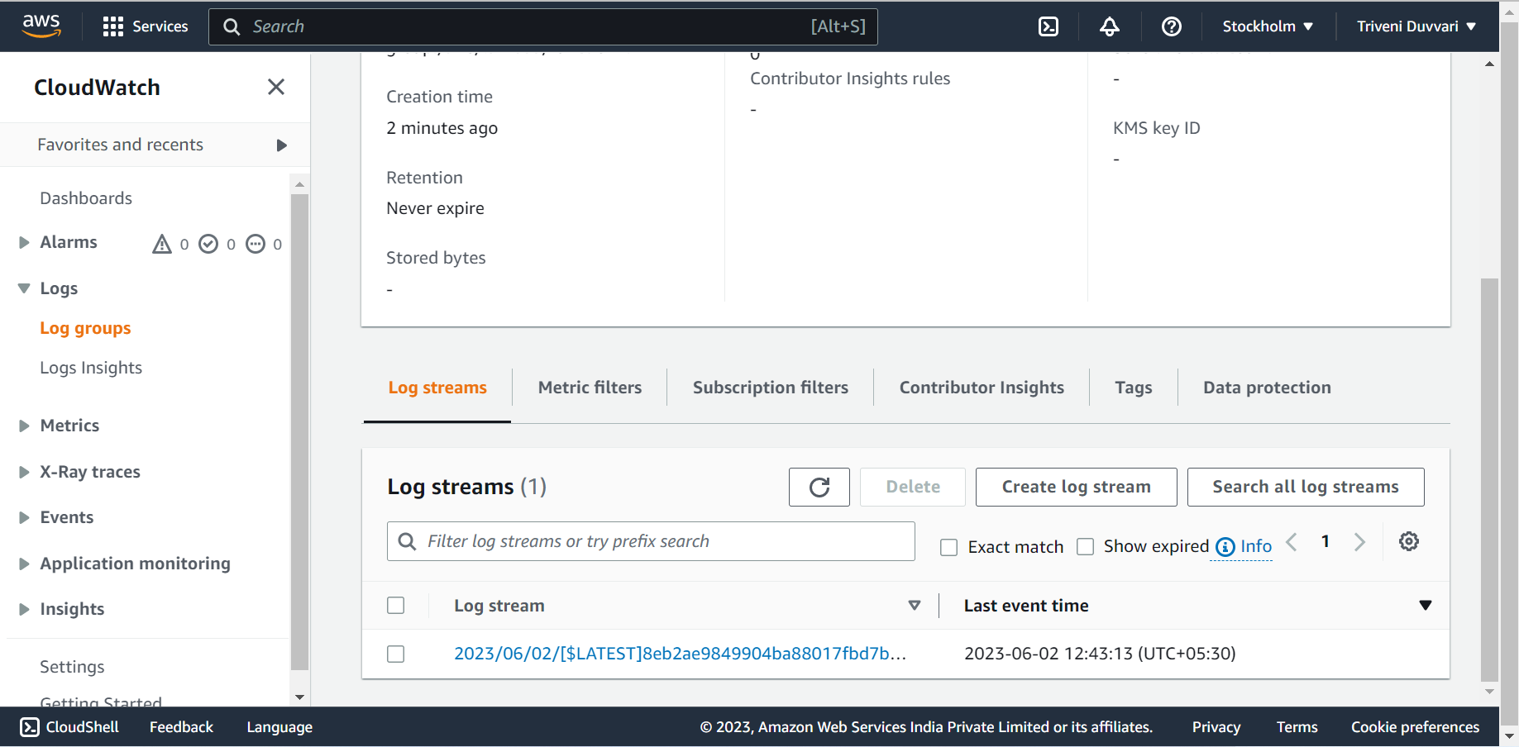

Click on log stream

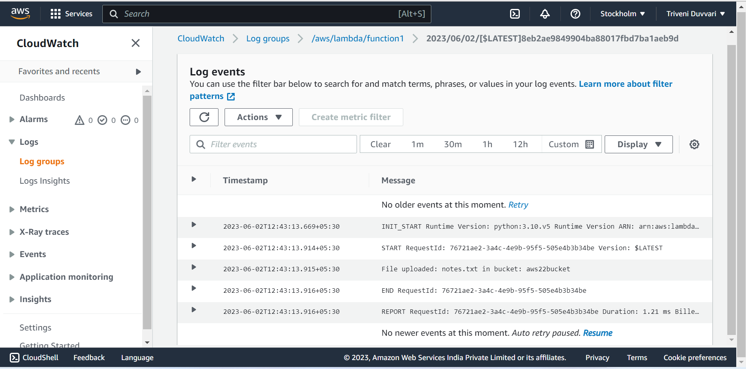

We can observe the details of the logs of the function and Name of the that uploaded in S3 bucket

3.**Deploy the same application to Elastic beanstalk Service**

First we have to create a role in IAM with the following permissions:

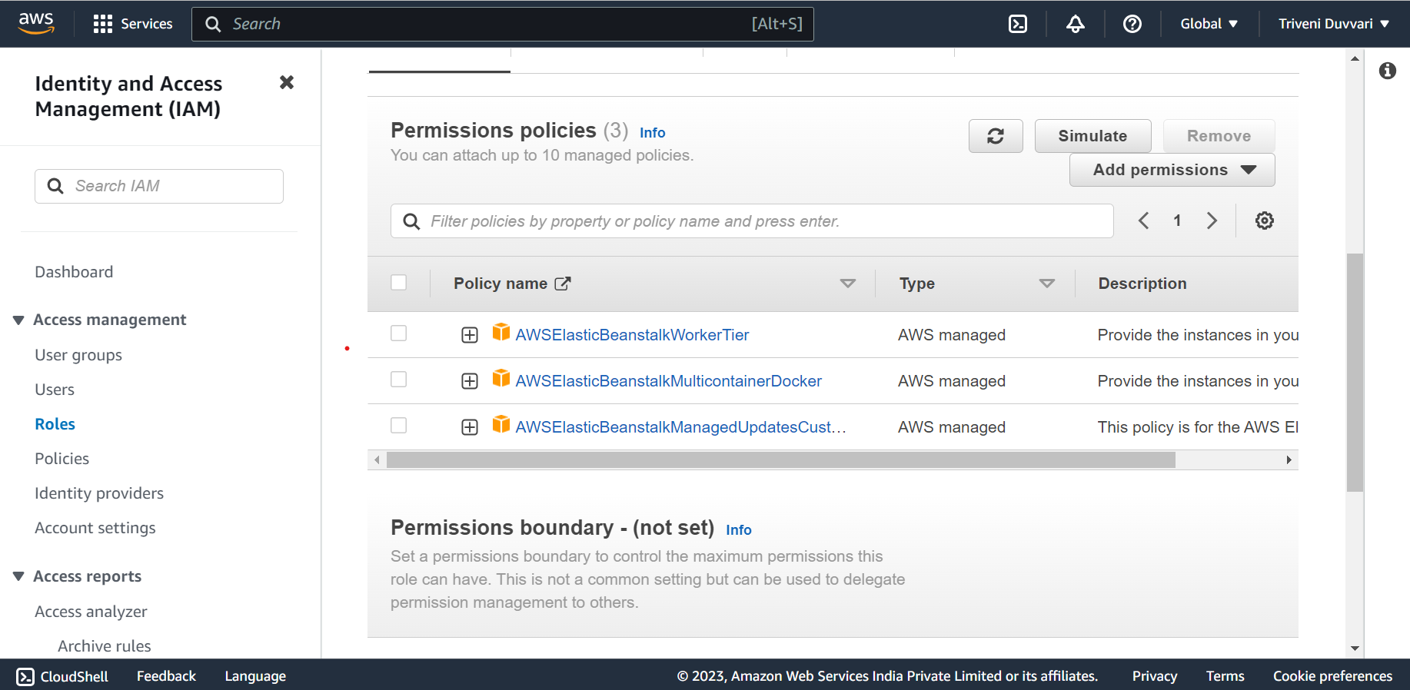

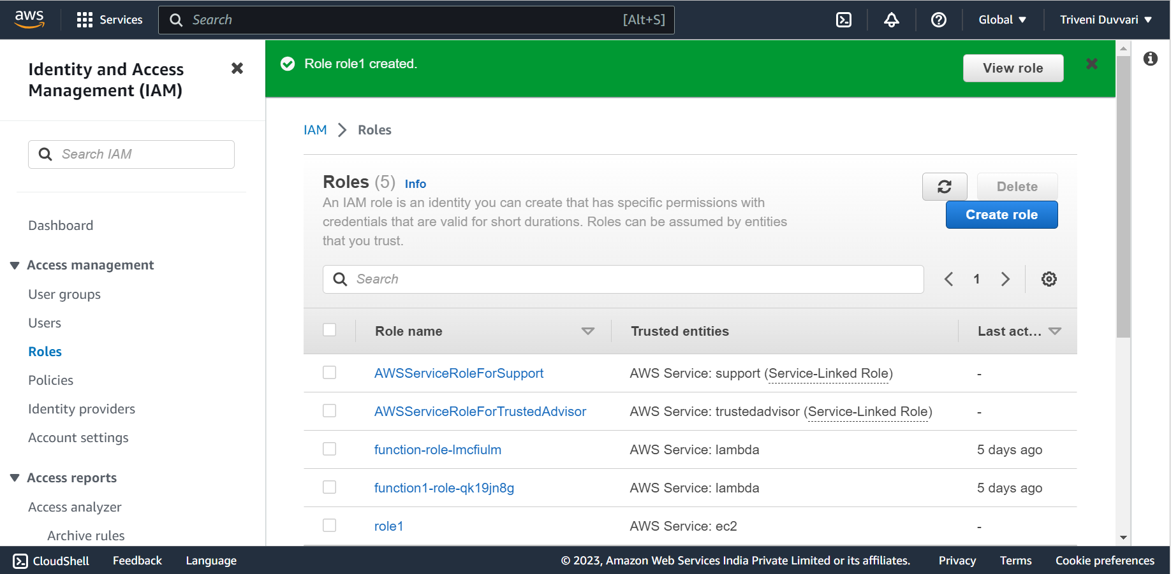

Go to Elastic beanstalk Service and click on “create environment”

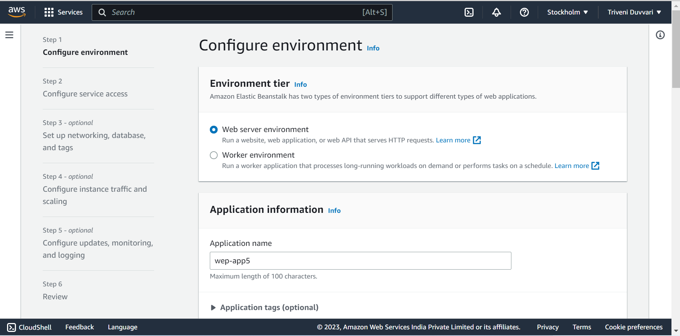

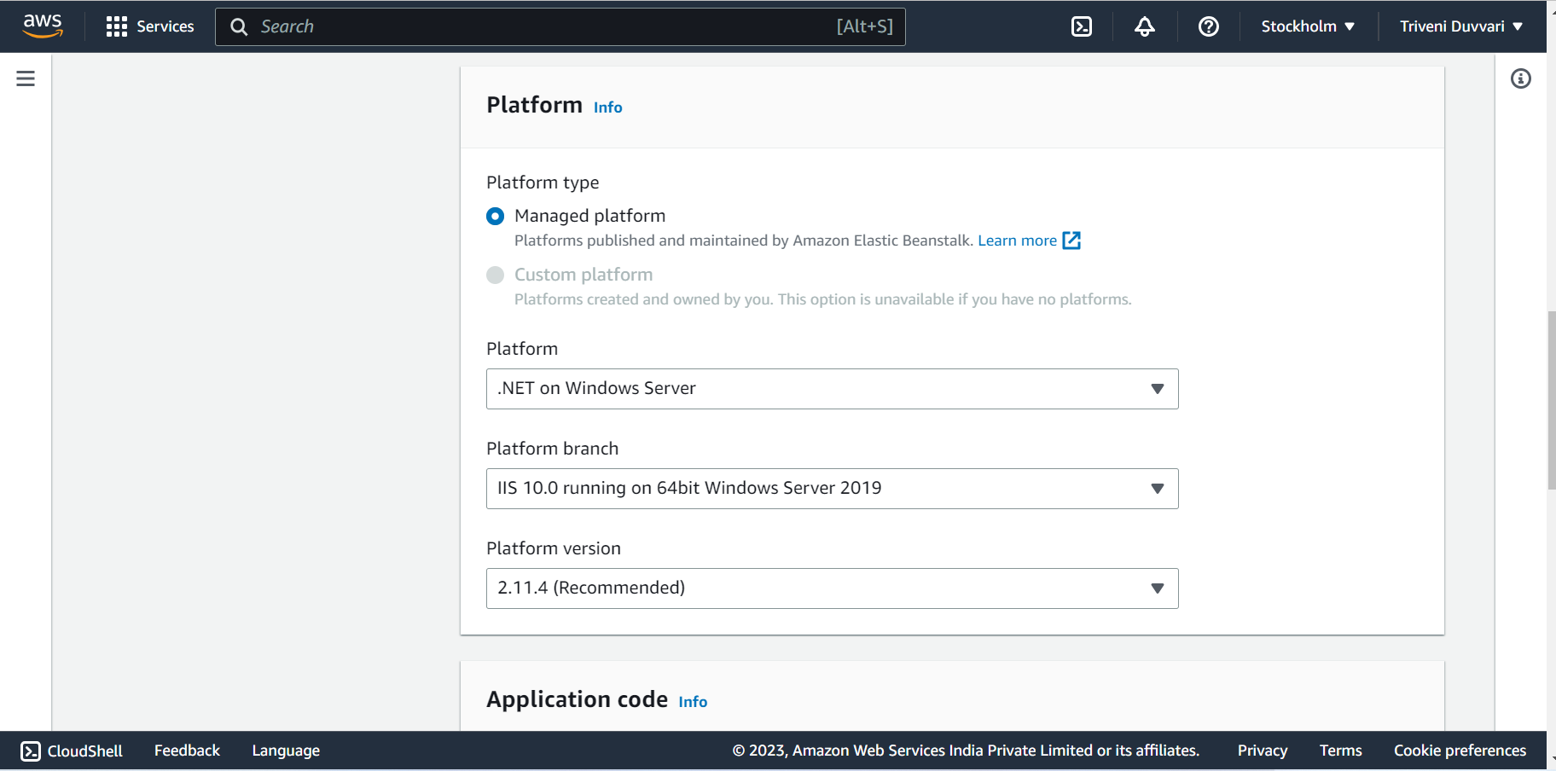

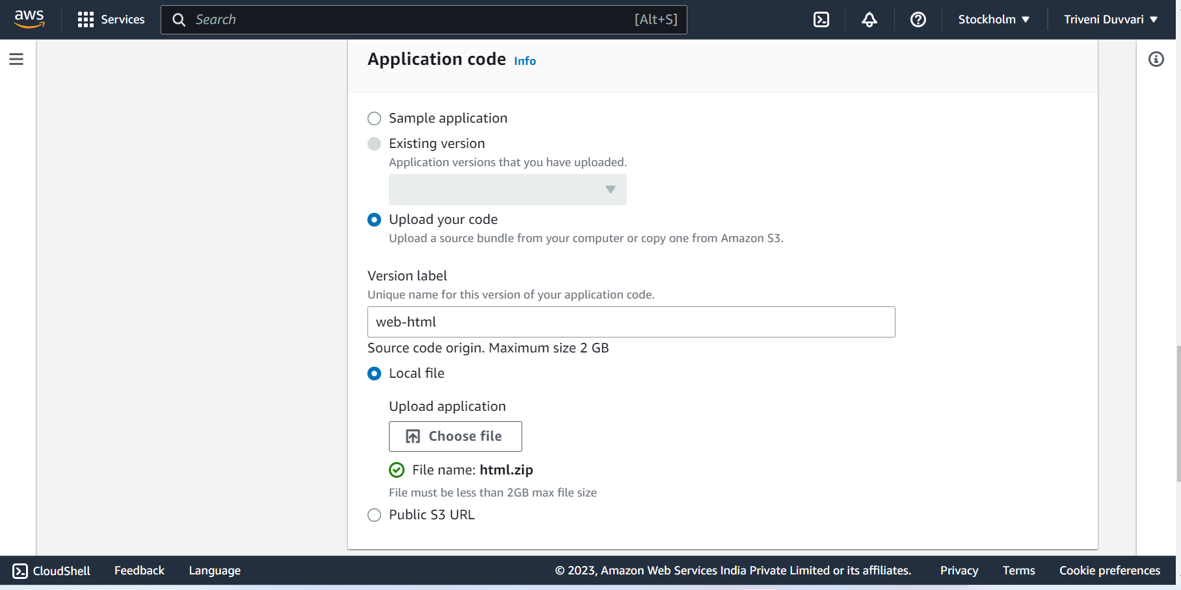

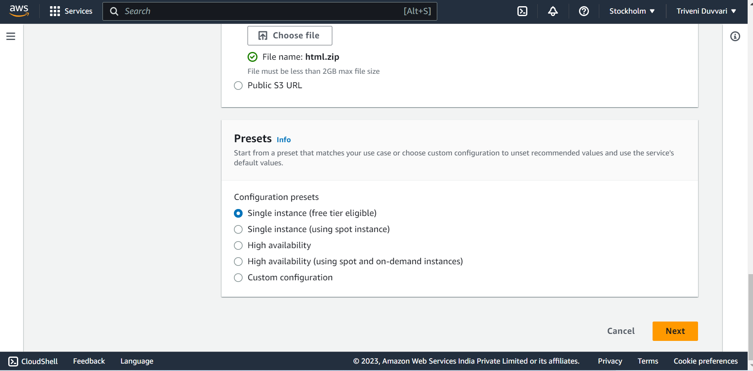

Fill the details Accordingly

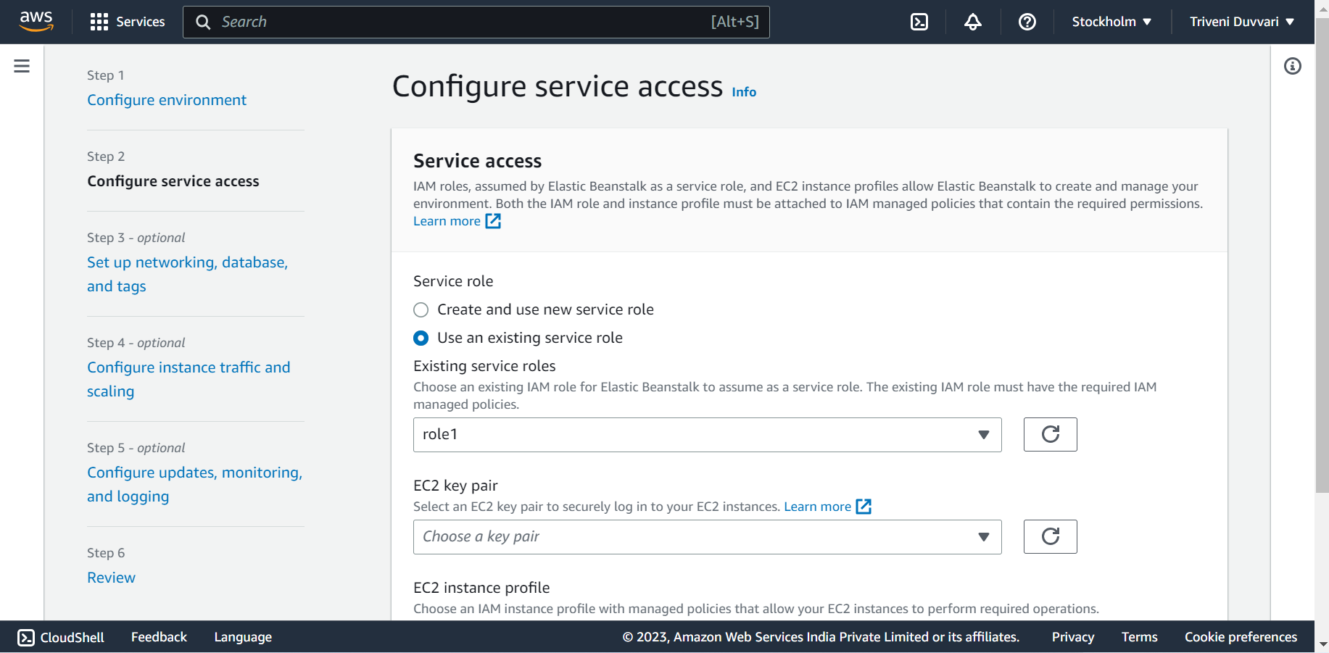

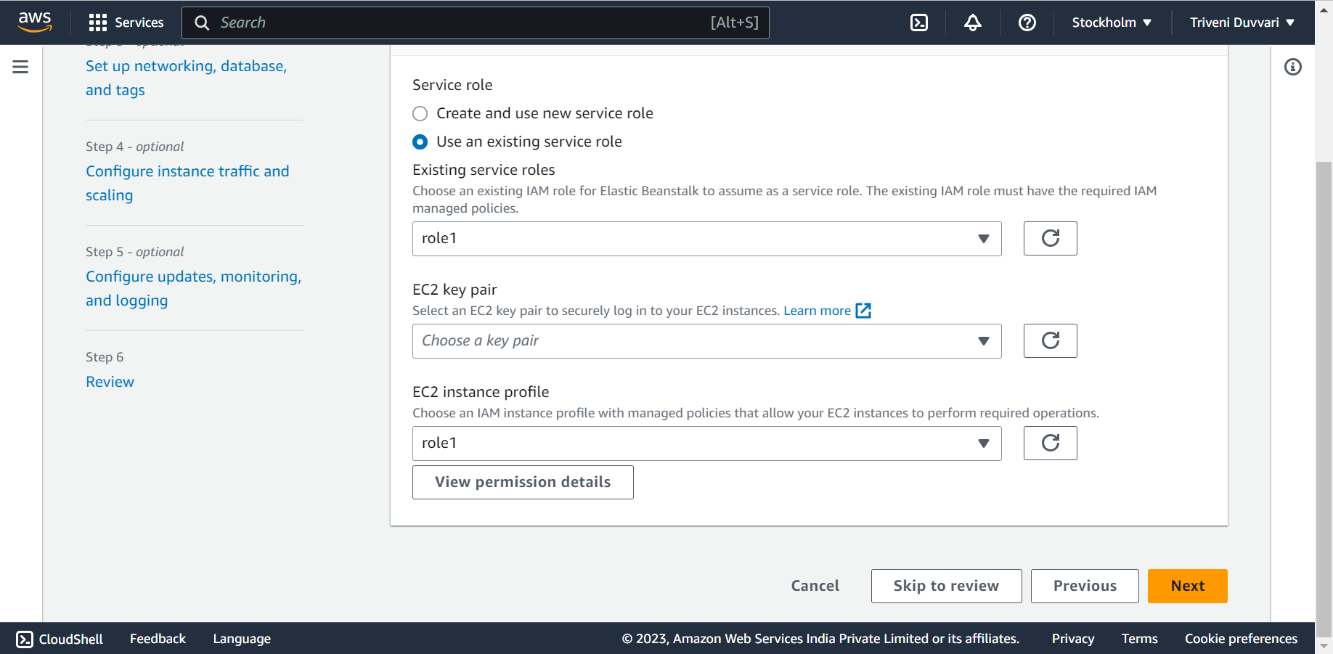

In configure service access, select the role that we have created for the ‘existing service roles’ and ‘EC2 instance profile’

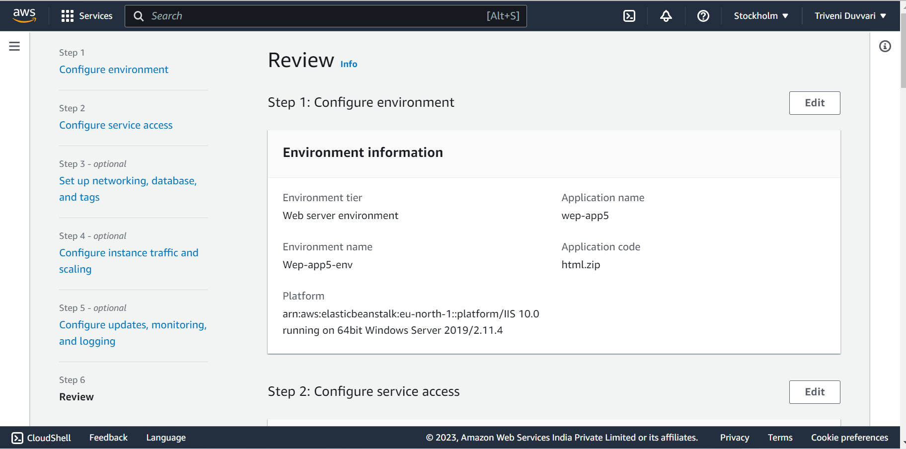

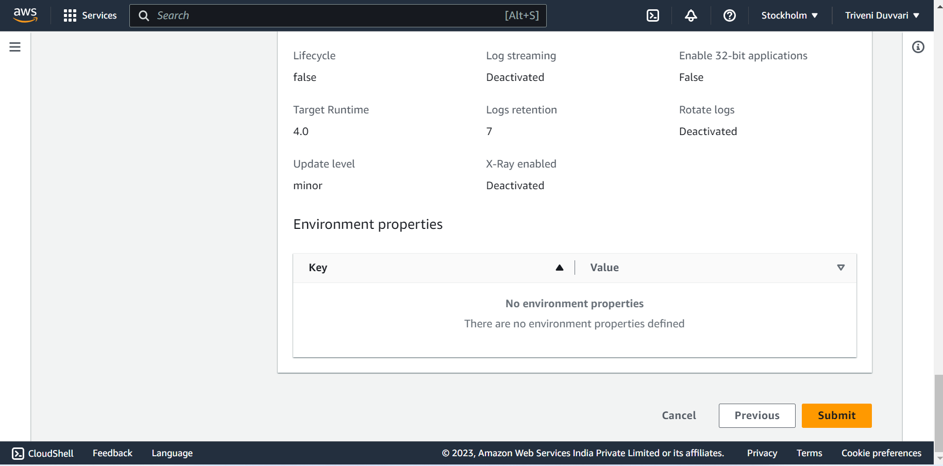

Review the environment settings click on submit.

Once the deployment is complete, Elastic Beanstalk will provide you with a URL to access your application.

You can find this URL on the environment dashboard or in the "Domian" column of the environments list

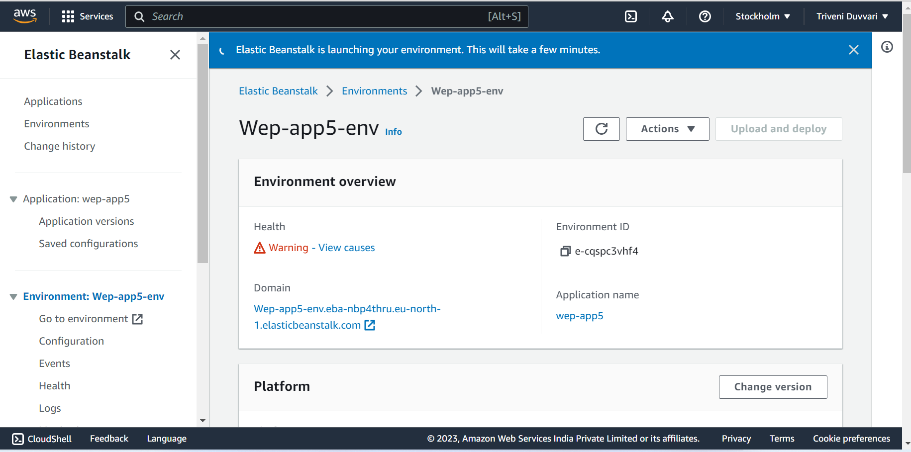

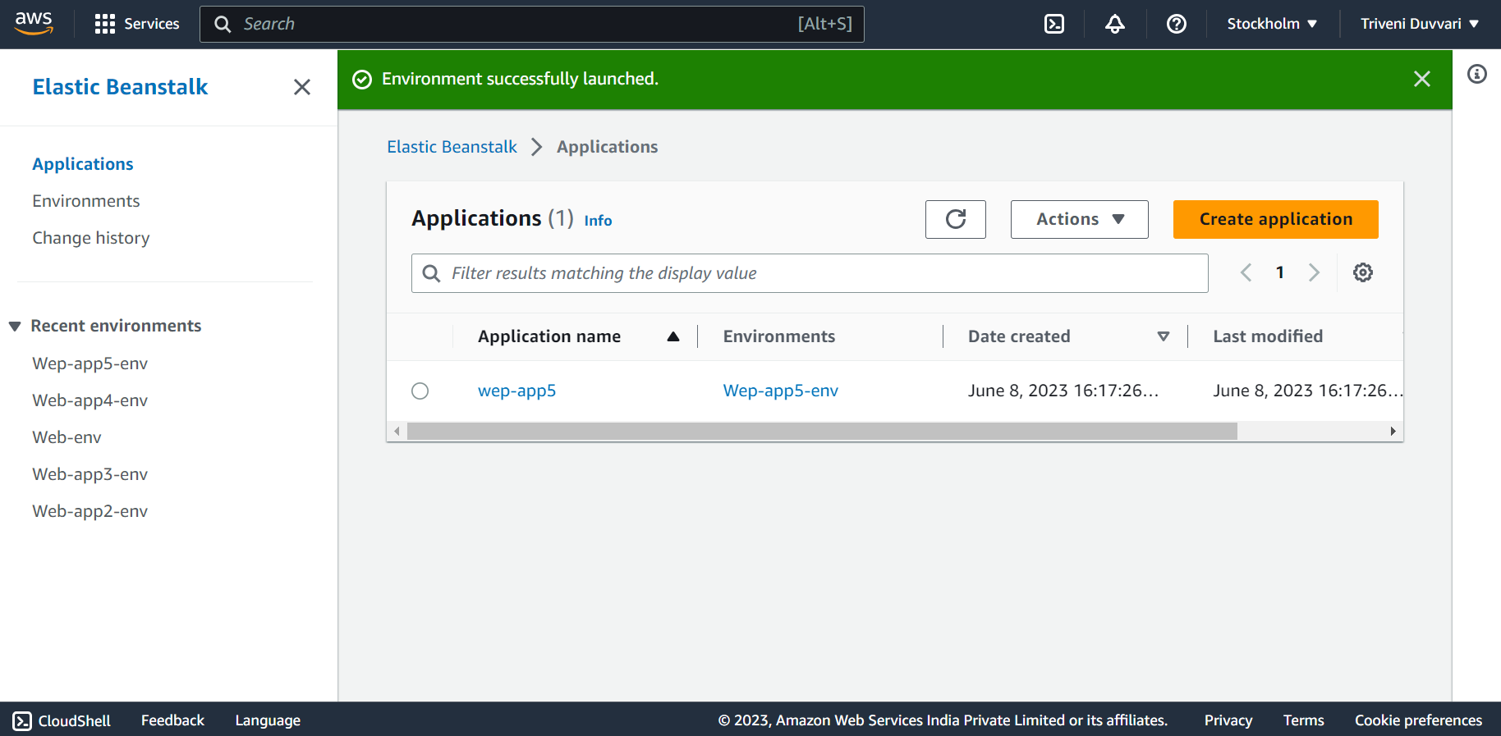

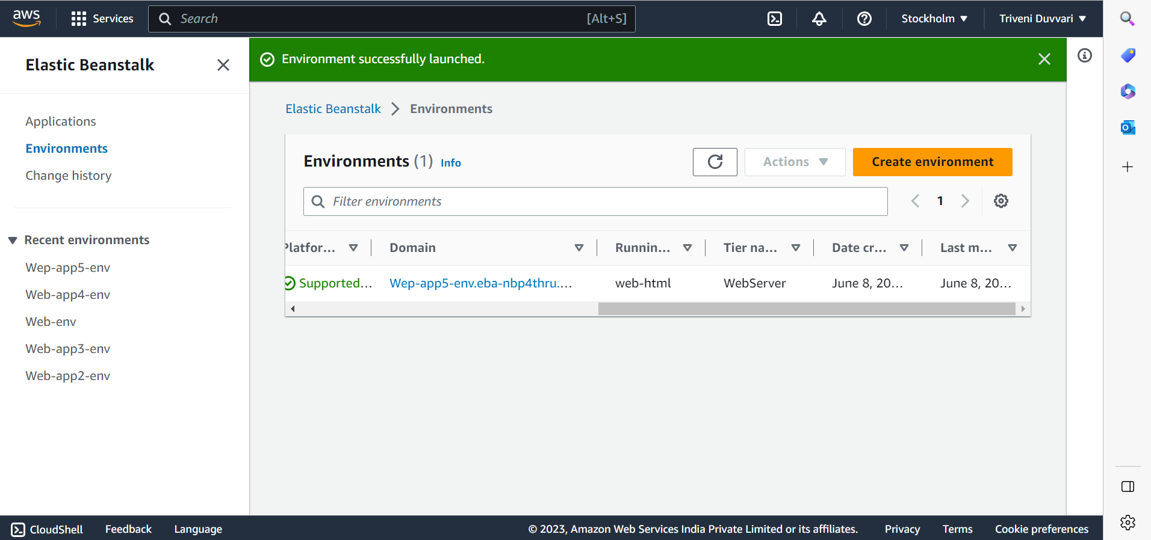



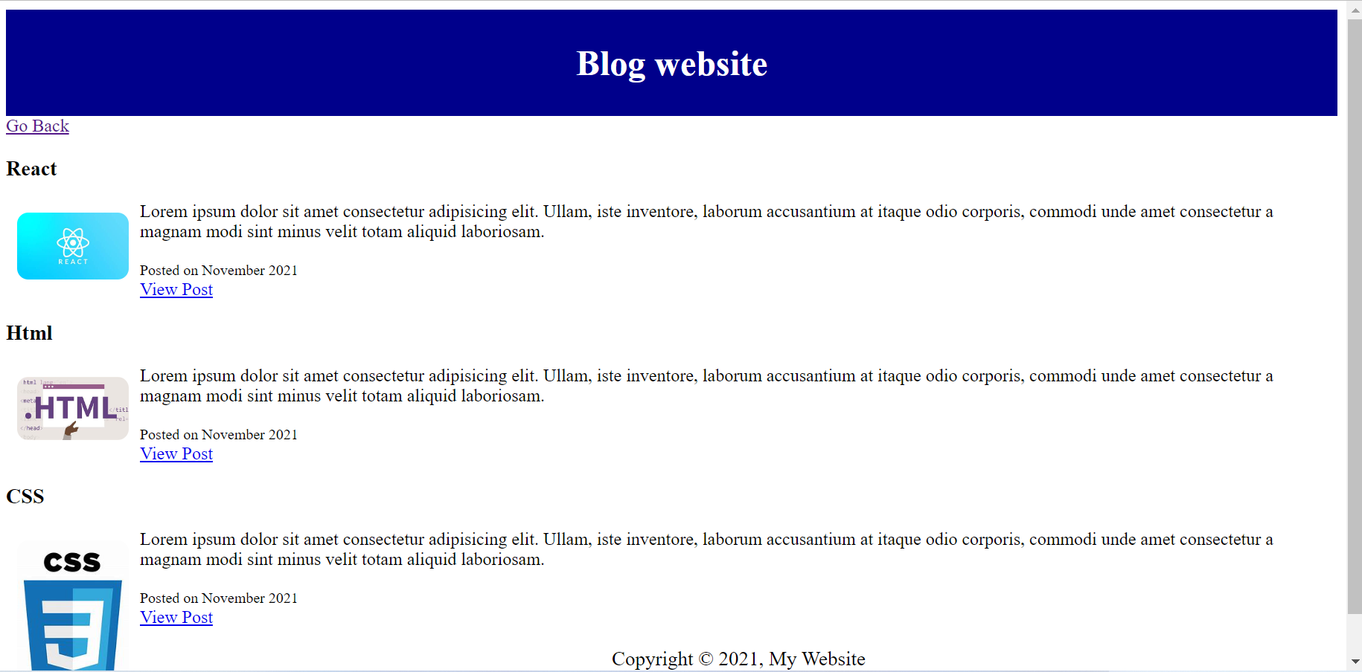

4. **Inside one of the subnets, create a VM and deploy an application code inside it (any existing application created by you before). Make sure to use appropriate NACLs and SGs.**

Sign in to the AWS Management Console.

Open the Amazon EC2 service.

Click on "Launch Instances" to start the instance creation wizard

Fill all the details accordingly.

In Network settings, Select the VPC and accordingly the subnet that we want to create the VM in.

